# **Tambour Street Diver**

# **Tambour Street Diver, automatic, 44mm, steel & rose gold**

# **Product details:**

The Black Blaze model brings a sophisticated touch to the Tambour Street Diver range. Polished pink gold contrasts with a sporty feel, creating an uncompromisingly modern effect. A versatile new take on the iconic Tambour silhouette, it combines traditional diving watch features with creative and unexpected design.

Movement:

* Mechanical self-winding movement
* Functions: hours, minutes, seconds
* Power reserve: 50 hours
* Number of jewels: 27
* Frequency: 28,800 vibrations/hour

Case:

* Material: Stainless steel & 18K rose gold
* Black PVD coating
* Diameter: 44mm
* 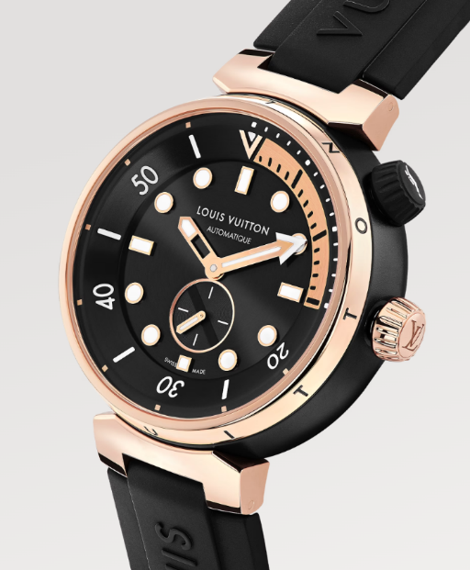Thickness: 12.8mm
* Sapphire crystal, anti-reflective coating
* Tinted transparent back
* Water resistant to 100 meters

Dial:

* Black dial
* Unidirectional rotating flange
* Small seconds counter at 6 o'clock
* Luminescent indexes and hands

Bracelet:

* Interchangeable rubber strap equipped with Louis Vuitton patented system
* Stainless steel ardillon buckle with black coating